Rethinking Coal Extraction & Use In The Face Of Climate Change
By John Maketo

Increased incidences of droughts, shifting seasons, floods, more hot days and heat waves have made the impacts of climate change and variability more evident. The impacts of Climate Change in Zimbabwe are likely to stall the country's development, pose a serious risk to food security and adaptive capacity.
At the international level, Zimbabwe has committed to negotiations on climate change having been among the first countries to sign and ratify the United Nations Framework Convention on Climate Change (UNFCCC) in 1992 and also acceded to the Kyoto Protocol in 2009. Through acceding to various instruments, Zimbabwe has also continued to support the United Nations efforts to curb the escalation of greenhouse gas (GHG) emissions. Taking heed of the glaring impacts of climate change, the Government of Zimbabwe developed a National Climate Change Response Strategy (NCCSR) in 2014 to guide national response measures in addressing the impacts of climate change. However, translation of this response strategy into action remains a dream yet to be realised. Zimbabwe is famous for producing super blueprints which but drastically fails at implementing the same. One of the guiding principles of the NCCSR is “Mainstreaming climate change into policy and legal framework as well as development planning.” It has however been appalling to note that the policy directions assumed this far are in contradiction with this guiding principle. Zimbabwe has planned the building of 15 new coal plants (of which 6 are still in the pre-permit stage) while the country is already grappling with the effects of climate change on a society dominated by agriculture.
The country's vulnerability to the adverse effects of climate change makes adaptation a national priority, demanding policy direction at the highest level and the integration of climate change issues into national development planning processes at national, provincial, district and local levels. Regrettably, the impacts of climate change are evidently felt at the local level and most felt by the poor communities due to their low adaptive capacity.
The energy sector stands at the centre of the climate change discourse in Zimbabwe, because it is the major contributor of GHG emissions. It contributes the biggest share (60.7 per cent) of the country’s total GHG emissions, followed by agriculture 20.7 per cent, industrial processes 16.6 per cent and waste 1.9 per cent. Greenhouse gas emissions from the energy sector emanate from combustion of carbon based fuels as well as fugitive emissions during coal mining and handling processes. It is there clear that any serious and meaningful climate change response strategy must embrace the reduction of GHG emissions. Government must stop funding and expanding fossil fuel powered projects. Recently, Zimbabwe commissioned a power station extension project in Hwange. The coal fuelled power station extension project funded by China to the tune of 1.5 billion was celebrated for the possibility of creating up to 7000 jobs directly and indirectly and for feeding an additional 600MW into the national grid. However, the social, economic and environmental cost of increased coal extraction and use far outweigh the purported benefits.
Over the years coal mining in Hwange District has posed serious negative impacts on the physical, biological, and social aspects of the environment which have not be adequately addressed because of the ‘purported’ economic benefits which are associated with coal mining. The following environmental impacts of coal extraction and use must be put into consideration with regards to reduction of fossil energy use. Coal is the largest contributor to climate change and also the least efficient source of energy. Coal has been recognised as the deadliest electricity source on the planet, killing up to 280,000 people per 1000 terawatt hours of electricity generated. The World Health Organisation (WHO) has shown that air pollution kills around 7 million people a year, and both mining, preparation, transport and combustion of coal are extremely polluting.
Recounting the costs of coal mining and use
- Air pollution
An independent environmental impact assessment conducted by the Centre for Natural Resource Governance revealed that atmospheric air has been affected by the emissions from the Zimbabwe Power Company (ZPC) furnaces. The continuous emissions will in the long run contribute to acid rain, ozone depletion and global environmental problems that can potentially lead to reduced rainfall and an increase in temperatures. The burning of coal by ZPC emits pollutants. These pollutants include particulate matter (PM) and ground-level ozone (O3) — the key ingredients of smog - along with nitrogen oxides (NOx), sulphur oxides (SOx), volatile organic compounds (VOCs) and carbon monoxide (CO). As such the air in Hwange is heavily polluted
- Greenhouse Gas Emissions
The burning of coal in coal powered stations contributes an enormous amount of greenhouse gas emissions, namely carbon dioxide and methane, into the atmosphere.
- Surface and Ground water pollution
Water contamination is also caused by coal dust settling on the surface water environment as well as from leaching and toxic drainage of particulates. Contaminated water sources in turn posses a health hazard to people as well as animals. Acidic water from coal mines produced by the leaching of sulphide minerals present in the coal have a direct impact on drinking water quality, aquatic life and corrosion of equipment and structures. Residents of Dheka village in Hwange have experienced loss of cattle due to drinking contaminated water in Dheka River.
- Destruction of wetlands
Increased salt load and metals from leaching of toxic pollutants destroy wetlands and their ecosystem.
- Noise and vibration
Cumulative effect of mining activities produces high noise levels from blasting, drilling, crushing and movement of vehicles to the detriment of surrounding communities. Learning in schools is disrupted, communication is hampered and socialisation disturbed while vibration often leads to cracking of living houses and other utility buildings in the vicinity.
Health impacts
Inhaling of coal dust and methane gas has several health complications on host communities
- Increased asthma, wheezing & cough in children.
- Inhalation of respirable coal dust causes pneumoconiosis or black lung disease (permanent scarring of lung tissues) in coal mine workers and host communities.
- Radiation exposure - coal also contains low levels of uranium, thorium, and other naturally occurring radioactive isotopes whose release into the environment may lead to radioactive contamination. Coal plants emit radiation in the form of radioactive fly ash, which is inhaled and ingested by people and incorporated into crops.
Figure 1. Why Zimbabwe Should Shift Towards Cleaner Energy
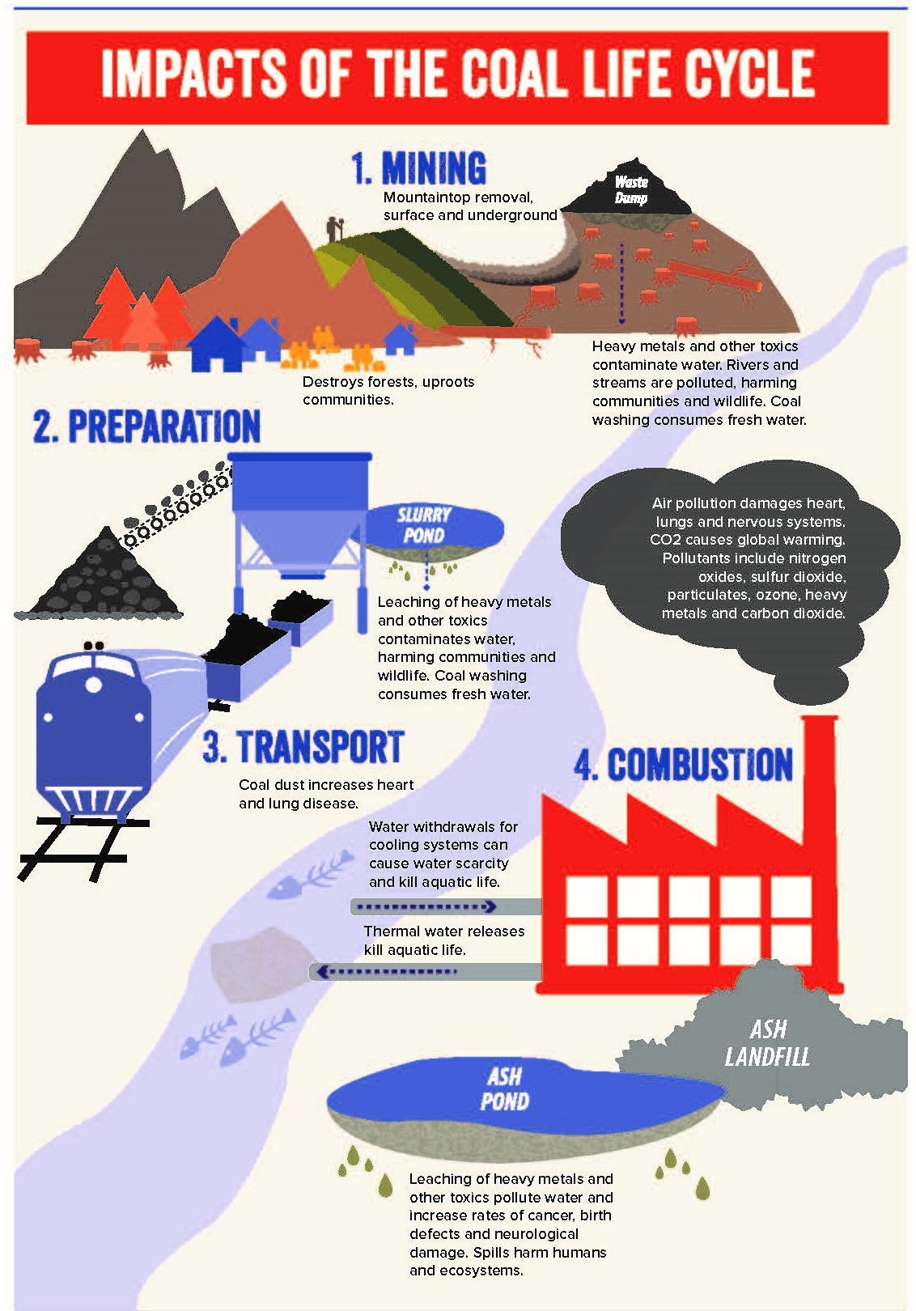
Given these and other environmental impacts of non renewable energy extractivism and use, coal in particular, it is worthwhile for Zimbabwe to start embracing and tap into other forms of renewable technologies. The shift towards cleaner and greener energy will protect our agro based economy in the face of crippling effects of climate change. The use of renewable energy is low (less than 1%). The major renewable energy resource currently used is hydropower from Kariba. There are other known sites where electricity could be produced on the Zambezi River Basin such as the Batoka, Devil’s, Mupata and Katambora gorges as well as on perennial rivers in the eastern highlands and the large to medium scale irrigation dams across the country which lie unutilised. Being a tropical country with plenty of sunshine hours, Zimbabwe should seriously invest in solar energy technology and reduce the demand for fossil powered energy. The current ambitious investment drive should not overlook the glaring environment impacts of extractivism and its bearing on climate change and human welfare.

(John Maketo is an economic development practitioner and writes in his own capacity & can be contacted on jpmaketo@gmail.com)

National Climate Change Response Strategy, (2014). http://www.climatechange.org.zw/sites/default/files/National%20Climate%20Change%20Response%20Strategy.pdf
http://www.zw.undp.org/
https://www.herald.co.zw/ed-commissions-15bn-project-•expansion-to-feed-600mw
https://www.forbes.com/sites/jamesconca/2012/06/10/energys-deathprint-a-price-always-paid/
http://www.who.int/airpollution/en/
Centre for Natural Resource Governance, Environmental Impact Assessment Report for Hwange community
Anders S.G (2007). Global environmental impact assessment of the Pb-free shift , Soldering & Surface MountTechnology , Vol 19 Issue 2 , 18 -28
www.healthandenvironment.org

